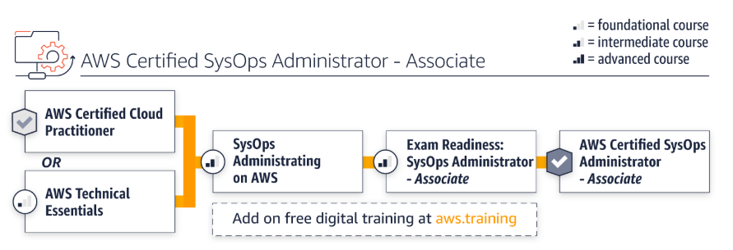

|  |  |  |  |
| --- | --- | --- | --- |
| Training | Type | Duration | Register |
| AWS Technical Essentials | Classroom | 1 day | [Find a class](https://www.aws.training/training/schedule?courseId=10012&src=path-ops) |
| **Systems Operations on AWS** | Classroom | 3 days | [Find a class](https://www.aws.training/training/schedule?courseId=10020&src=path-ops) |
| **Exam Readiness: AWS Certified SysOps Administrator – Associate** | Classroom | 4 hours | [Find a class](https://www.aws.training/training/schedule?courseid=18144&src=path-ops) |
| **Free digital training** |  |  | [Start learning for free at aws.training](https://www.aws.training/training?src=path-ops) |

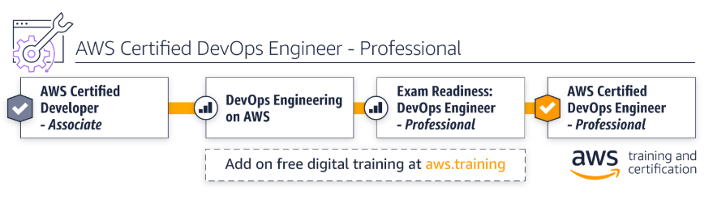

|  |  |  |  |
| --- | --- | --- | --- |
| Training | Type | Duration | Register |
| **DevOps Engineering on AWS** | Classroom | 3 days | [Find a class](https://www.aws.training/training/schedule?courseId=10018&src=path-ops) |
| **Exam Readiness: AWS Certified DevOps Engineer – Professional** | Classroom | 1 day | [Find a class](https://www.aws.training/training/schedule?courseid=19030&src=path-ops) |